ALA0

8





The new streaming platform for everyone

SWD-ALA08 Version 2024-02 D. Boot/W.Brock

CASE DESCRIPTION 1

WHAT HAS ALREADY BEEN WORKED OUT 1

WHAT'S NEW? 1

WHAT NEEDS TO BE TESTED 1

METHOD IN THIS PROJECT 2

SPRINT 1 3

SPRINT 2 TO 5 3

ATTACHMENTS 4

ANNEX 1: PSCHEDULE OF REQUIREMENTS – FUNCTIONALITY 4

ANNEX 2: PPROGRAM OF REQUIREMENTS - VINFORMATION 5

ANNEX 3 – DATABASE DESIGN 6

ANNEX 4: ALA07 AND YOUR QUALIFICATION FILE 7

Table of contents

**ORIENTATION TO THE ALA ........................................................................................................................................ 1**

# SWD-ALA08 Version 2024-02 D. Boot/W.Brock

Orientation to the ALA

## Case description

You work at FastDevelopment. Founded by a number of independent investors, the HoBo streaming service aims to cater to a specific group of users amid tough competition from Netflix and DisneyPlus: lovers of high-quality series who strive for excellent streaming quality. According to marketing experts, there is still room for improvement here. HoBo aims to be on the market within a year, but given the importance of quality to their success, they want to include a longer testing period. The assignment is therefore not to develop a complete streaming website and application, but to create a usable, limited web version for various testing purposes: functional, technical and in terms of user experience. Based on these tests, it will be decided whether to make a multi-million euro investment in the next phase.

## What has already been worked out

With input from experienced software developers in a think tank, several 'white papers' have already been drawn up in which functionality and design are largely laid down. The schedule of requirements is crucial for your team, which can be found in Appendix 1 and 2. In addition, a database design is also available, which can be found in Appendix 3. During this project, you will also receive the following:

* A logo
* A database of test data
* A number of files to simulate streaming.

## What's new?

In this assignment there is a great deal of attention for **testing**. After all, a lot depends on it. This means that this ALA will pay very close attention to missing and non-working functionalities. So you will have to test well.

## What needs to be tested

In preparation for this project, you will also orient yourself on the different types of tests that are involved in software development. The following course on LinkedIn Learning is a good one to start with: <https://www.linkedin.com/learning/programming-foundations-software-testing-qa>

For this project, it means that in addition to design and realization, you will now deliver at least 2 additional products:

* An acceptance test, in which you demonstrate that all requested functionality works
* A test protocol, which can be carried out by users afterwards.

# Method in this project

This ALA we work according to the SCRUM methodology. This means that we regularly have a delivery moment where we deliver one or more functionalities completed.

We also hold a stand-up every first ALA block of the day. In addition, we conclude each sprint with an evaluation, in which you reflect on the result after each sprint.

The ALA is divided into at least 5 sprints, the first sprint backlogs are determined in consultation with the project leader, the backlogs of the other sprints are up to you. During the final sprint, you prepare the application for delivery to the customer. This sprint planning is flexible and can be adjusted 'on the go'.

|  |  |  |  |  |  |  |  |
| --- | --- | --- | --- | --- | --- | --- | --- |
|  | Week 1 | Week 2 | Week 3 | Week 4 | Week 5 | Week 6 | Week 7 |
| Sprint 1 |  |  |  |  |  |  |  |
| Sprint 2 |  |  |  |  |  |  |  |
| Sprint 3 |  |  |  |  |  |  |  |
| Sprint 4 |  |  |  |  |  |  |  |
| Sprint 5 |  |  |  |  |  |  |  |

In the first week of the project, you draw up a schedule for your sprints based on the deliverables. The description of this follows below.

# Sprint 1

Sprint 1 asks you to deliver the following components:

* A functional design that includes:
* User stories (Use Appendix 1 as a basis)
* Use case diagram
* Sitemap for the entire website
* Wireframe for each page
* A Visual Design of the homepage.

# Sprint 2 to 5

From sprint 2 onwards, you choose which user story/functionality you are going to implement. Acceptance criteria must always be drawn up for this, on the basis of which approval takes place. The customer/client is always involved in this. So there is a test plan for every sprint.

# ATTACHMENTS

## Appendix 1: Schedule of requirements – functionality.

* A **main screen**, showing various scrollbar channels such as last watched, now trending, editors pick.
* A **profile screen**, where the user can set preferences for genres, so that the correct series are shown. Here you will also find personal preferences such as privacy and display settings.
* A **search screen**, where content can be searched in different ways
* A **history screen**, where the user can see when and for how long he has seen what. And statistics, such as how many hours a day he was active on the service.
* A **stream window** where the chosen content is displayed.
* A **series info** window, which can be displayed next to the stream window and contains information about the series in question (actors, other series) and links.
* Note: For the pilot in 2022, all data about actors/directors will not yet be shown within the platform. A link to IMDB will suffice. This can still be realized in a later version.

The functionality is assigned to the different users as follows.

* **Visitors** can see the **main screen** , with a slideshow of the most popular series, can log in / register there.
* Logged-in **users** can visit all of the above screens. And use the features there.
* The **content manager** manages all the series that are available.
* The **administrator** is in charge of all user accounts, privacy

## Appendix 2: Schedule of Requirements - Design

For the design, there is a strong focus on existing streaming services. The interfaces are not very different from each other from a technical point of view, and it is advised to take a good look at this for the screen layouts. We do want to be distinctive by recognizable, light green accent color and our own, clearly different font from the existing one, the project is internally called 'The Green Netflix'. Below you will find an example of Visual Design. Based on research into other streaming services, create your own visual designs.

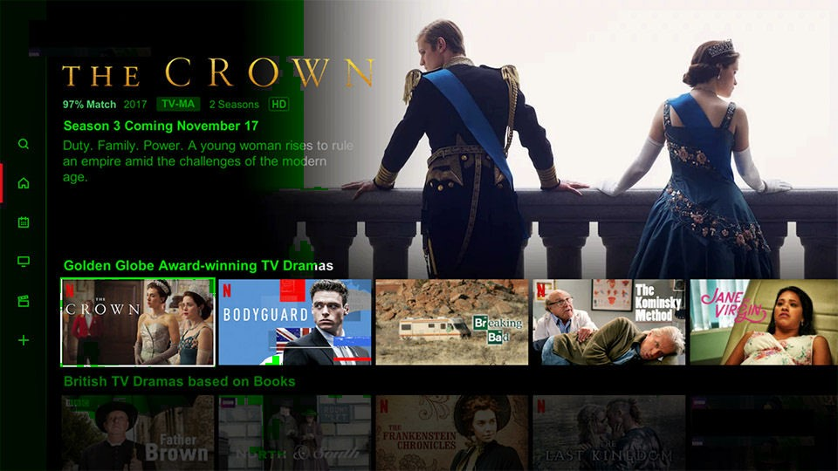

## Appendix 3 – Database Design

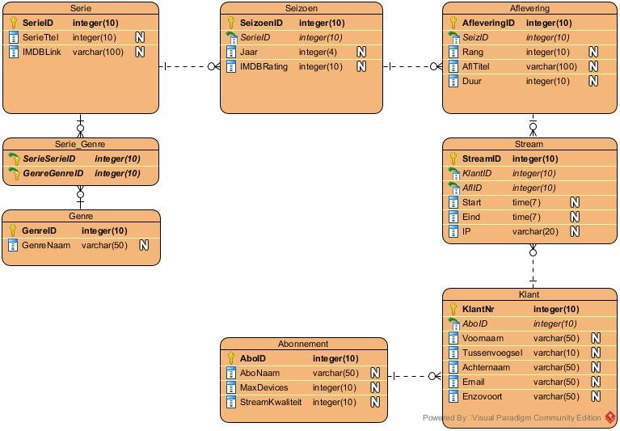

## Appendix 4: ALA07 and your qualification file

**Relationship with the qualification file ALA7**

|  |  |
| --- | --- |
| **K1-W1 | Requirements/wishes and planning** | |
| The requirements and wishes have been incorporated into the user stories. |  |
| The user stories meet the criteria (who, what, why and realistic). |  |
| Based on the user stories, a complete and realistic planning was made |  |
| Progress has been monitored and the right choices/considerations have been made based on priorities. |  |

|  |  |
| --- | --- |
| **K1-W2 | Design** |  |
| The user stories have been translated into an appropriate, unambiguous and complete design (in line with wishes and requirements). | Oh |
| Relevant or applicable schematic techniques (e.g., activity diagram, class diagram, ERD, use case diagram) have been used. | Oh |
| The choices made in the design are substantiated with valid arguments, taking into account, for example, ethics, privacy and security. | Oh |

|  |  |
| --- | --- |
| **K1-W3 | Realization** |  |
| Sufficient content of the user stories has been realized within the set/planned time. |  |
| The delivered functionalities meet the requirements and wishes as described in the relevant user story. |  |
| The quality of the code is good. This manifests itself in, among other things: OOP, object structure, MVC, validation, efficiency, error handling and feedback, security (secure programming). | Oh |
| The code is structured according to code conventions. | Oh |
| The code is neat, readable, structured and provided with meaningful commentary. |  |
| Version control has been applied effectively. |  |

|  |  |
| --- | --- |
| **K1-W4 | Test** |  |
| The test cases in the test plan are in line with the user stories and contain all scenarios. | P |
| The steps, the desired result and test dates have been named. Not only the main scenario, but also alternative scenarios | P |
| The test report contains the correct results and conclusions. | P |

|  |  |
| --- | --- |
| **K1-W5 | Suggestions for improvement** |  |
| The right improvement proposals have been made from testing. | P |
| The right improvement proposals were made from the delivery. | P |
| The right suggestions for improvement have been made from the reflection. | P |